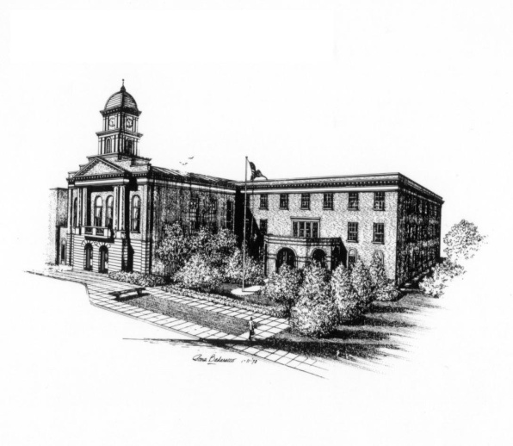
Snyder County Planning Commission
Courthouse, P.O. Box 217 • Middleburg, Pennsylvania 17842-0217
Phone: (570) 837-4256 or (570) 837-4257
Fax: (570) 837-4345

Ju1y 17, 2025

To whom it may concern,

The Snyder County Planning Commission’s Regularly Scheduled meeting for July 21, 2025 at 7pm in the Snyder County Courthouse basement meeting room has been cancelled. Items scheduled to be on the Agenda for this meeting will appear on the August Meeting Agenda.

If you have any questions please don’t hesitate to give my office a call. Or send me an email at lkaufman@snydercounty.org .

Respectfully,

Lincoln Kaufman
Snyder County Planning Director

Cc: File

